**Project Report Template**

1. **Introduction**
   1. **Overview**

Wholesaling or distributing is the sale of goods or merchandise to retailer to industrial, commercial, institutional or other professional businessman to other wholesalers (wholesale business) and related subordinated services. In general, it is the sale of goods in bulk to anyone, either a person or an organization, other than the end consumer of that merchaindise. Wholesaling is buying goods in bulk quantity, usually directly from the manufacturer or source, at a discounted rate. The retailer then sells the goods to the end consumer at a higher price making a profit.

The comsumption and production of marketed food are spatially separated. Production is primarily in rural areas while consumptionis mainly in urban areas.

* 1. **Purpose**

Marketing insights benefits both parties by meeting your target audiences needs and wants while also profiting. This is especially true when marketing a previously unused or unknown innovation. Inother words the best market insights help those selling the invention and companies needing it.

**2** Problem Definition & Design Thinking

2.1 Empathy Map

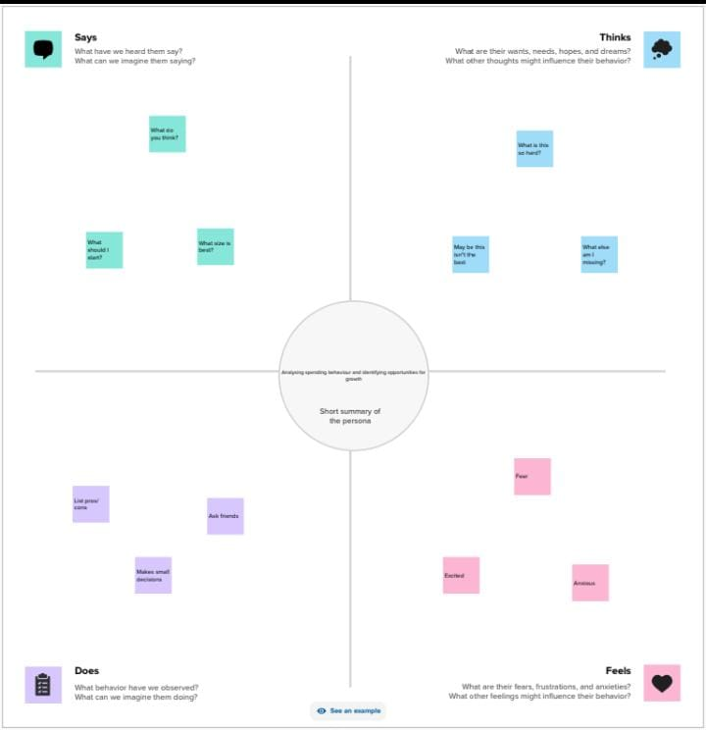

* 1. Idention &Brainstorming bridge

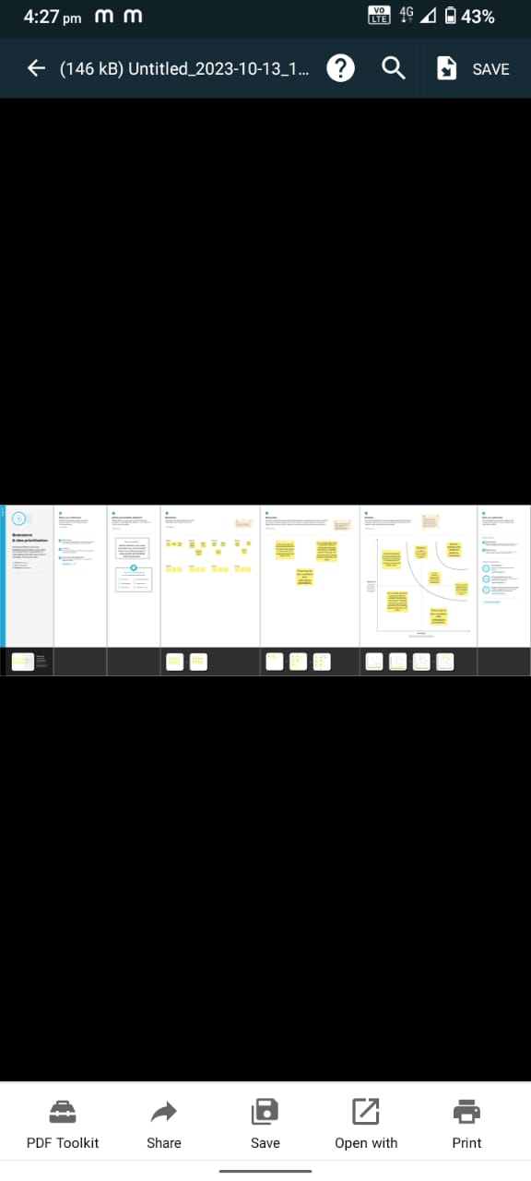

3.Result

The picture shows the KPI2



The picture shows the KPI3

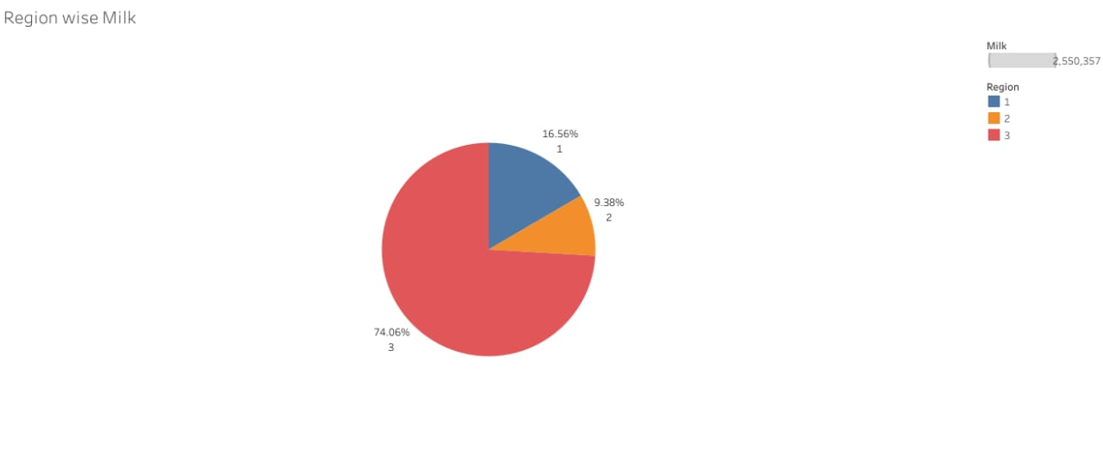

The bargraph shows the Regionwise detergent andpaper grocery

The pie chart 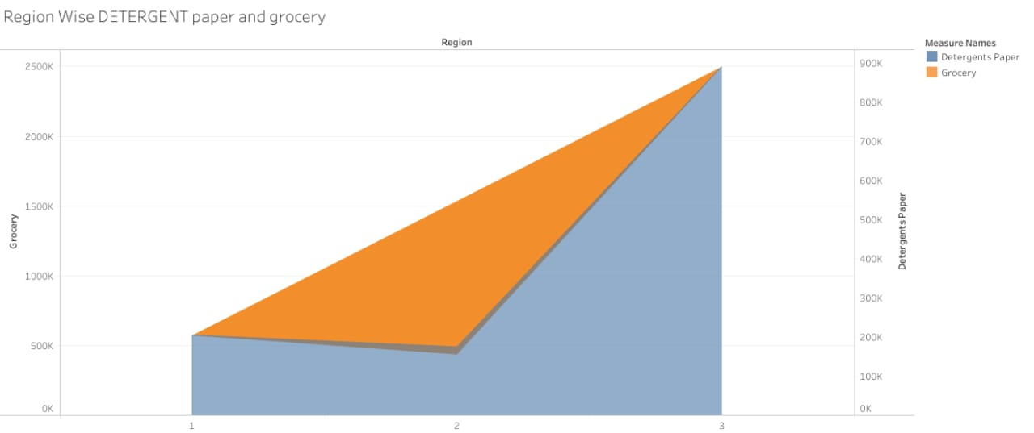

The pie chart shows the region wise milk

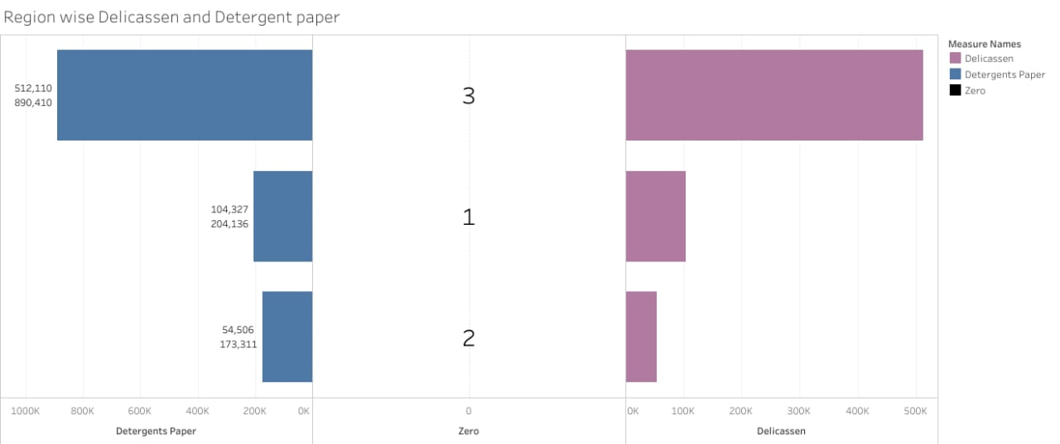

The bsr graph shows the channel wise frozen and delecassion

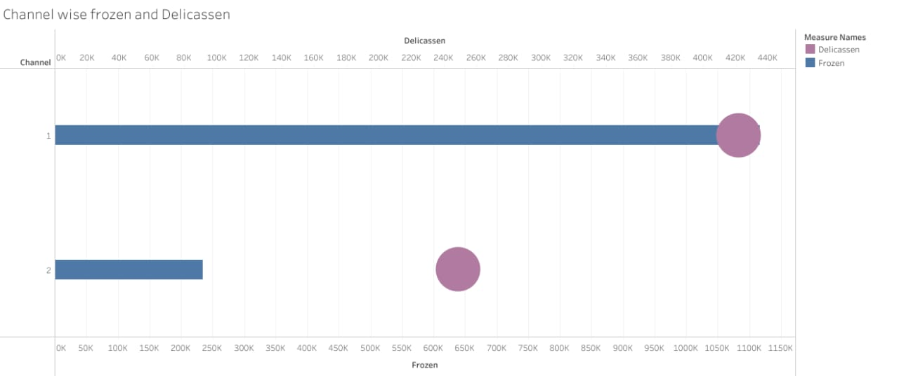

The bar graph shows region wise delecasion and detergent paper

1. **Advantages**
2. It increases your reach.
3. You can target your audience at the right time.
4. It improves communication at all stages of the buying process.
5. It’s cost-effective.
6. It’s easy to tack and monitor.
7. Marketing allows you to know customers better.
8. It lets the customer come to you.
9. Digital marketing can increase your revenue.

**Disadvantages**

1. The expense of accessing expert information.
2. Outdated information leading to bad decision-marking.
3. Easy lossess. A lot of people think that trading us the simplest method of making money in the stock market, but it is also the easiest way of losing money.
4. High tax liability. A tax liability is the sum of taxation that industry or an individual acquires based on current tax rules.
5. May only target a small population.
6. Need personal to conduct research.

**6 Coclusion**

In this project we will shows the visualizations are,

1. KPI
2. Region Wise Detergent Paper and Grocery.
3. Region Wise Milk.
4. Channel wise frozen and Delicassen.
5. Region Wisse Delicassen and Detergent Paper.